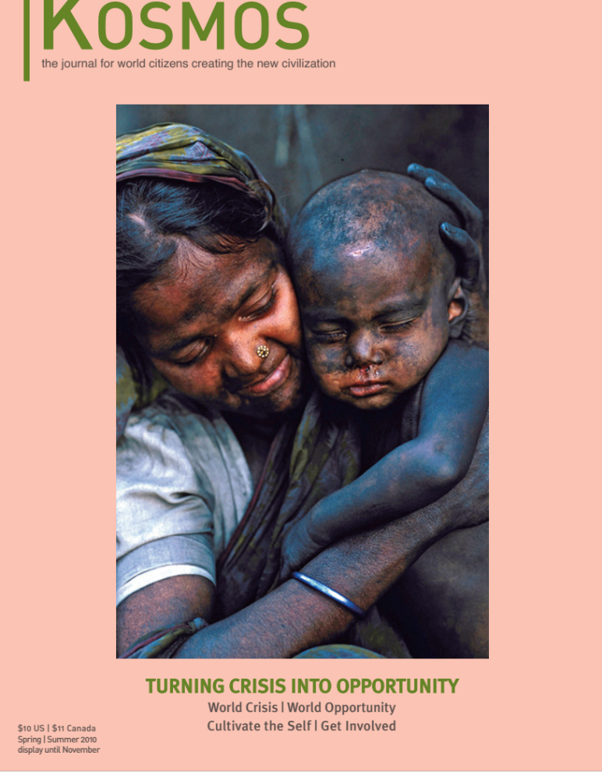

Dark Night of the Soul: Crisis and Opportunity of our Times

“In the middle of the road of my life I awoke in a dark wood where
the true way was wholly lost.” - Dante

In the middle of my life I found myself in a Dark Night of the Soul. I saw my world threatened by environmental degradation, war, economic collapse, and human suffering. All the structures I had built to keep myself safe and separate from my feelings of despair and hopelessness were crumbling. I came face to face with a feeling of primal anxiety – a fundamental underlying pain of the limitation of just being human and therefore limited in my ability to “fix” either my internal feelings of pain or the outer conditions of my world.

During this time of personal crisis I was inspired by the words of St. John of the Cross who had encountered his own version of the Dark Night of the Soul. His advice was comforting:

Do everything you can to get away from the darkness. When that does not work, if you choose to surrender, three things will happen. You will find, relief, release, and a strange feeling will come over you that you do not want it to end too soon for you sense there is value here for you.

I took my personal crisis – my loss of energy, feelings of despair and anxiety, and the ache in my heart, as an invitation to surrender – to slow down and feel more deeply. I stopped fighting against it. I chose to consciously co-participate with my own unfolding process. Unraveling the old antiquated ways in which I held myself separate from my own pain and separate from the world around me.

After three years I came out of my dark night of my soul and landed more fully in myself and in a stark intimate connection with all of life. The walls I had erected to keep me safe from pain had crumbled, my heart broke open and life began surging through me. I felt a new aliveness and authenticity. I was no longer living in the world; I was living as the world – an integral part of it all.

For me, crisis was an opportunity ushering me into my own evolutionary awakening.
I now respond to crisis by leaning into it as opposed to closing my eyes and heart and running away from it. I choose to meet crisis directly -- feel the impact in my body, heart, mind and soul and respond from a place of wholeness -- empowered and guided by my newly discovered, deep and profound, connection to all of life.

Geri Portnoy, M.A.
www.yogaofawakening.com

